GUESS PAPER - 2013

CLASS-X

SUBJECT: Science
Time : 3 Hrs MM: 100
MCQ ( 1-5 ) 1 mark each
Que. 1 Acetic acid was added to four test tubes containing the following chemicals:
a. Sodium carbonate b. Blue litmus solution c. Lime water d. Distilled water
Que.2 Which amongst these is/ are correct option(s) for carrying out a characteristic test for identification of a carboxylic acid (acetic acid) in the laboratory?
1. (a) only 2. (c) only 3. (a) and (b) 4. (c) and (d)
Que.3 On adding concentrated NaOH solution to a test tube containing phenolphthalein, the colour change observed by a student would be:
a. Pink to colorless b. Pink to blue c. Colour less to pink d. Red to blue
Que. 4 A student observed a focused slide of a stage of binary fission in Amoeba under a microscope as seen below:
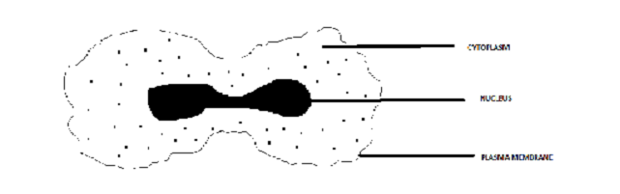
Which of the following is most appropriate statement with respect to the observation-
a) preliminary stage
b) intermediate stage where the nucleus is divided and cytoplasm is not
c) intermediate stage where the cytoplasm is divided and nucleus is not
d) final stage
Que. 5 A student while observing the properties of acetic acid would report that this acid smells like
(i) vinegar and turns red litmus blue
(ii) rotten egg and turns red litmus blue
(iii) vinegar and turns blue litmus red
(iv) rotten egg and turns blue litmus red

VSA (6 -10) 2 marks each
Que. 6 Give one example of a unisexual flower.
Que. 7 Draw the electron dot structure of the gas molecule which is liberated when zinc metal is treated with aqueous NaOH solution.
Que. 8 Find the period and group of the element whose atomic number is 12.
Que. 9 Refractive index of two material medium X and Y are 1.3 and 1.5 respectively. In which of the two, the light would travel faster?
OR
Que. 10 Write in one word or at the most in one sentence about the following
(i) Mirrors used by dentists to examine teeth
(ii) The smallest distance, at which the eye can see objects clearly without strain.
Que. 11 List two differences between acquired and inherited traits.
Short Answer questions each of 3 marks ( Q-11 to 18)
Que. 11 State how would you distinguish between Acetic acid and Ethanol in your laboratory. Give chemical equation of the reactions shown by them. Write the chemical equations involved.
Que. 12 Complete the reaction(s) given below and classify them as Combustion / Oxidation / Addition / Substitution reaction.
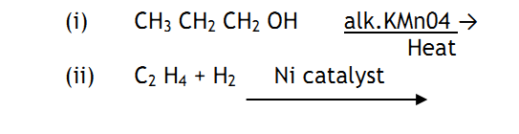
Que. 13 Explain why?
(i) ‘Danger’ signal are red in colour.
(ii) Convex mirrors are commonly used as rear – view mirrors.
Que. 14 Study the ray diagram given below and answer the following questions -
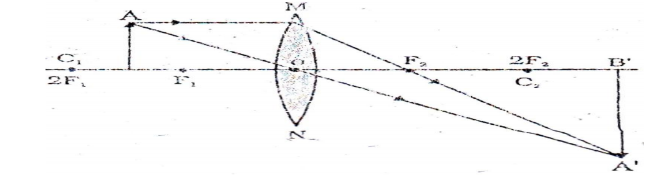
(i) State the type of lens used in the figure.
(ii) List two properties of the image formed.
(iii) In which position of the object will the magnification be -1?
Que. 15 What is meant by power of accommodation of the eye? How is it related to the focal length of the eye lens?
Que. 16 “Fossils are related to evolution”, justify this statement. Give the two ways by which age of the fossils can be estimated?
Que. 17 ‘Variation is beneficial to the species but not necessarily for the individual”, give three reasons to justify it.
Que. 18 Two elements with symbol X (atomic no. 11) and Y (atomic no. 13) are placed in the III period of the modern periodic table -
(i) Which amongst the two has more metallic character?
(ii) Calculate the valency of each element.
(iii) Element ‘Y’ is smaller than ‘X’ in terms of atomic size. Is the statement true, justify?
Long answer question 5 marks (5 x3 =15)
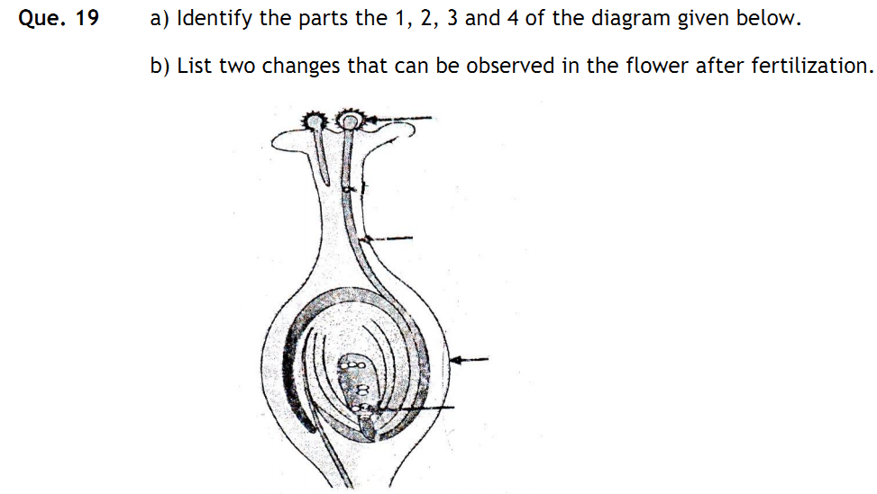
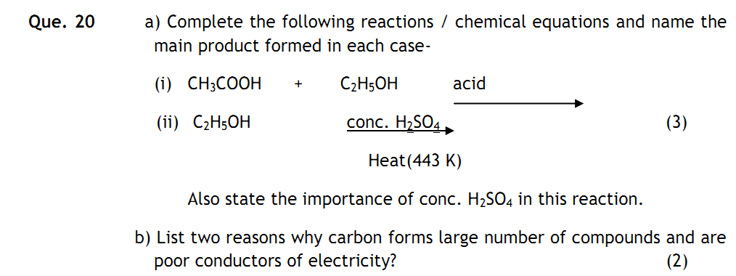
Que. 21 A 2.0 cm tall object is placed perpendicular to the principal axis of a concave lens of focal length 10 cm. The distance of the object from the mirror is 15 cm. Find the nature, position and size of the image formed.
Represent the situation with the help of a ray diagram. (5)

